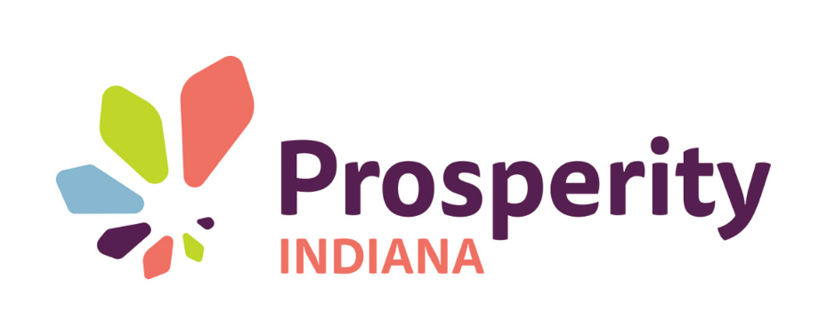
Empower Indiana
Statewide Grant Challenge

Indiana boasts a strong reputation for innovation combined with heart. With over 200 dedicated member agencies, the Prosperity Indiana network is committed to a society in which all persons have the opportunity to live and work in an environment that provides economic and social opportunity—a critical measure of our landscape.

Social issues and solutions are the key to our economic growth and community stability. And now, Prosperity Indiana is excited to announce a partnership with the CareSource Foundation that will accelerate our ability to move forward in each of those areas.

The new Empower Indiana Grant Challenge adds yet another opportunity for the Prosperity Indiana network to help all Hoosiers move forward.

EMPOWER INDIANA GRANT CHALLENGE
Prosperity Indiana and the CareSource Foundation have partnered to tackle issues head-on by launching the Empowering Indiana Grant Challenge.

CareSource was launched thirty years ago in Dayton, Ohio, as one of the only non-profit health plans in the United States designed to address both health and life issues of low-income individuals and families. Since then they have expanded into four other states (Kentucky, Indiana, Georgia and West Virginia) providing Medicaid, Marketplace and Medicare Advantage services.

The CareSource Foundation has developed a great new relationship with Prosperity Indiana and is now piloting this grant challenge specifically with Prosperity Indiana members in Indiana. The CareSource Foundation has committed $100,000 to help fund these grants in areas of greatest need, impact and innovation.

The Empower Indiana grant opportunity will provide funding for innovative solutions to unique community challenges that involve social determinants of health. The process consists of two stages:
- Request for Proposal (RFP) process including grant submission
- Concept Presentation and Q&A for finalists

FOCUS
The CareSource Foundation invests in nonprofit organizations that focus on the social determinants of health—those conditions that have significant positive or negative impact on overall quality of life—such as:
- Eliminating poverty/economic stability
- Access to health care services
- Addressing critical health trends to build or rebuild healthy communities
- Positive birth outcomes
- Domestic violence/child abuse
- Access to economic and job opportunities
- Sustainable housing solutions
- Population health issues
- Transportation disparities
- Mental and behavioral health
- Health and cultural literacy

CRITERIA
The Empower Indiana project must contain elements that meet critical, creative and/or previously unfunded community needs including:
- Innovative approach to a pressing community need
- Engaged community with proven support of direction
- Optional partnerships that will help drive the solution to fruition and/or ensure its success
- Connect directly to the social determinants of health focus
- Requesting organization must be a 501(c)3 member of Prosperity Indiana
- Financial integrity

GRANT AWARD
- Empower Indiana grants will be awarded in amounts up to $50,000 (total grant pool: $100,000)
- Prosperity Indiana and The CareSource Foundation will partner in the review process which is designed to promote collaboration, innovation and learning
- Final grant awards will be announced in May 2019
- The CareSource Foundation, funder of this grant opportunity, will be available and actively engaged through each step of the RFP, selection and implementation phases. Additional technical support may be available as a result.

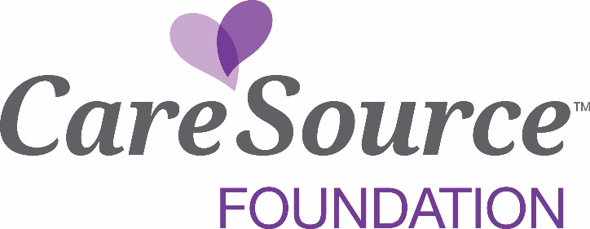

Empowering Communities
Statewide Grant Challenge
Request for Proposal

DEADLINE: Completed application must be received by 5 p.m. EST on April 4, 2019
QUESTIONS: Any questions about the application or the program should be directed to Kaytlin Eastes at keastes@prosperityindiana.org.
COMPLETED PROPOSALS MUST BE:

- Submitted by a 501(c)3 organization that is a Prosperity Indiana member
- Submitted via online portal at ProsperityIndiana.org/EmpowerIN
- Accompanied by the attachments listed as the last item on this template. Attachments can be in any format you prefer (PDF, Excel, etc.)

1. Background
- Contact information
  - Name, address, phone, email, website
- Mission Statement
- Brief overview of the organization’s purpose
- Board of Directors with title and/or affiliations
- Non-discrimination Policy
2. Project Title

3. Executive Summary
- Please give a high-level summary of your request using a maximum of eight bullets, two sentences each. This is a succinct overview of the issue, how you propose to address it, who it will help, etc. Write as if this was the only thing the reader will see. We value brevity in storytelling.

4. Narrative
- What issue do you seek to address?
- What is the plan? And how will this approach:
  - Spark new and promising ideas in this area of need?
  - Invite a diverse range of approaches, organizations and/or individuals to address this problem or issue? Note, community engagement is a crucial component of the project design.
  - Bring together coalitions of people and groups to act on this issue?
- What are your objectives?
- What will be different as a result?
- Who will provide leadership for this initiative?
- What counties are served by the request (select up to 5)
- What is the estimated timing to implement?
- Are there opportunities to expand to meet increased need? Replicate in other regions or states?

5. Project Budget
- Requested amount
- Total project budget as estimated

6. Evaluation
- How will you define success for this initiative?
- What assessment strategies will be used to measure success?

8. Attachments
- Scan of IRS 501(c)3 determination letter
- Current operating financial statements (balance sheet & statement of operations) to include both year-to-date and month-to-date
- Current W-9 form
- Most recent audited financial statements. A 990 is acceptable only if audit is unavailable.

